Exercise 4: Windows problem solving

**● A short description of your troubleshooting process.**

*Getting 503 Exception while browsing the “localhost” because DefaultAppPool wasn’t starting in the Internet Information Services (IIS) Manager.*

**● Tell us what's wrong**

*The Application pool was configured with Custom account rather than Built-in Identity.*

**● Explain what you did to fix it**

*DafaultAppPool has started after changing the Identity to “ApplicationPoolIdentity” as similar as the other pools.*

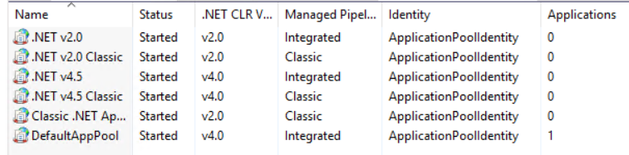

**Output**:

